**Task Report**

***State-Space Analysis and Control System Design***

**Fall 2023**

**CSE-310L Control Systems**

Submitted by

**Wali Ullah**

**20PWCSE1932**

Class Section: **B**

Submitted to:

**Engr.Waseem**

9Jan 2024

**Department of Computer Systems Engineering**

**University of Engineering and Technology, Peshawar**

## Tasks:

First we check the stability of a system.

After checking the stability we knew that the system is unstable.

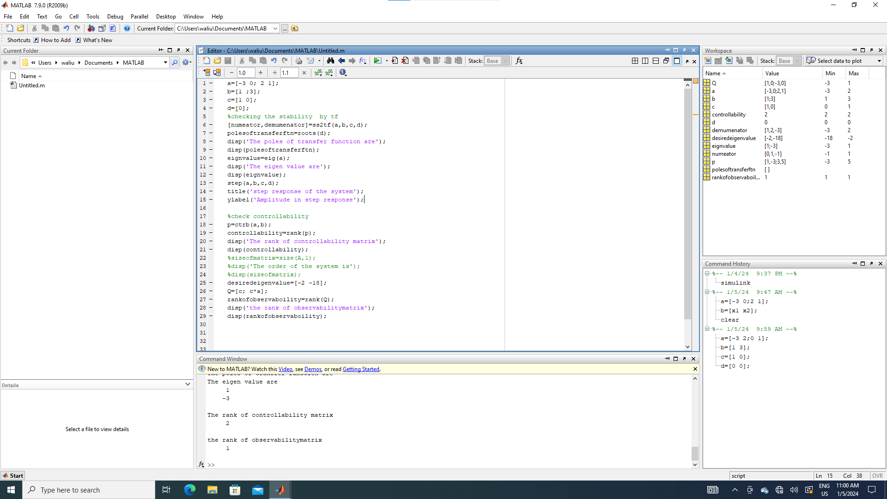

Figure : task1

Output

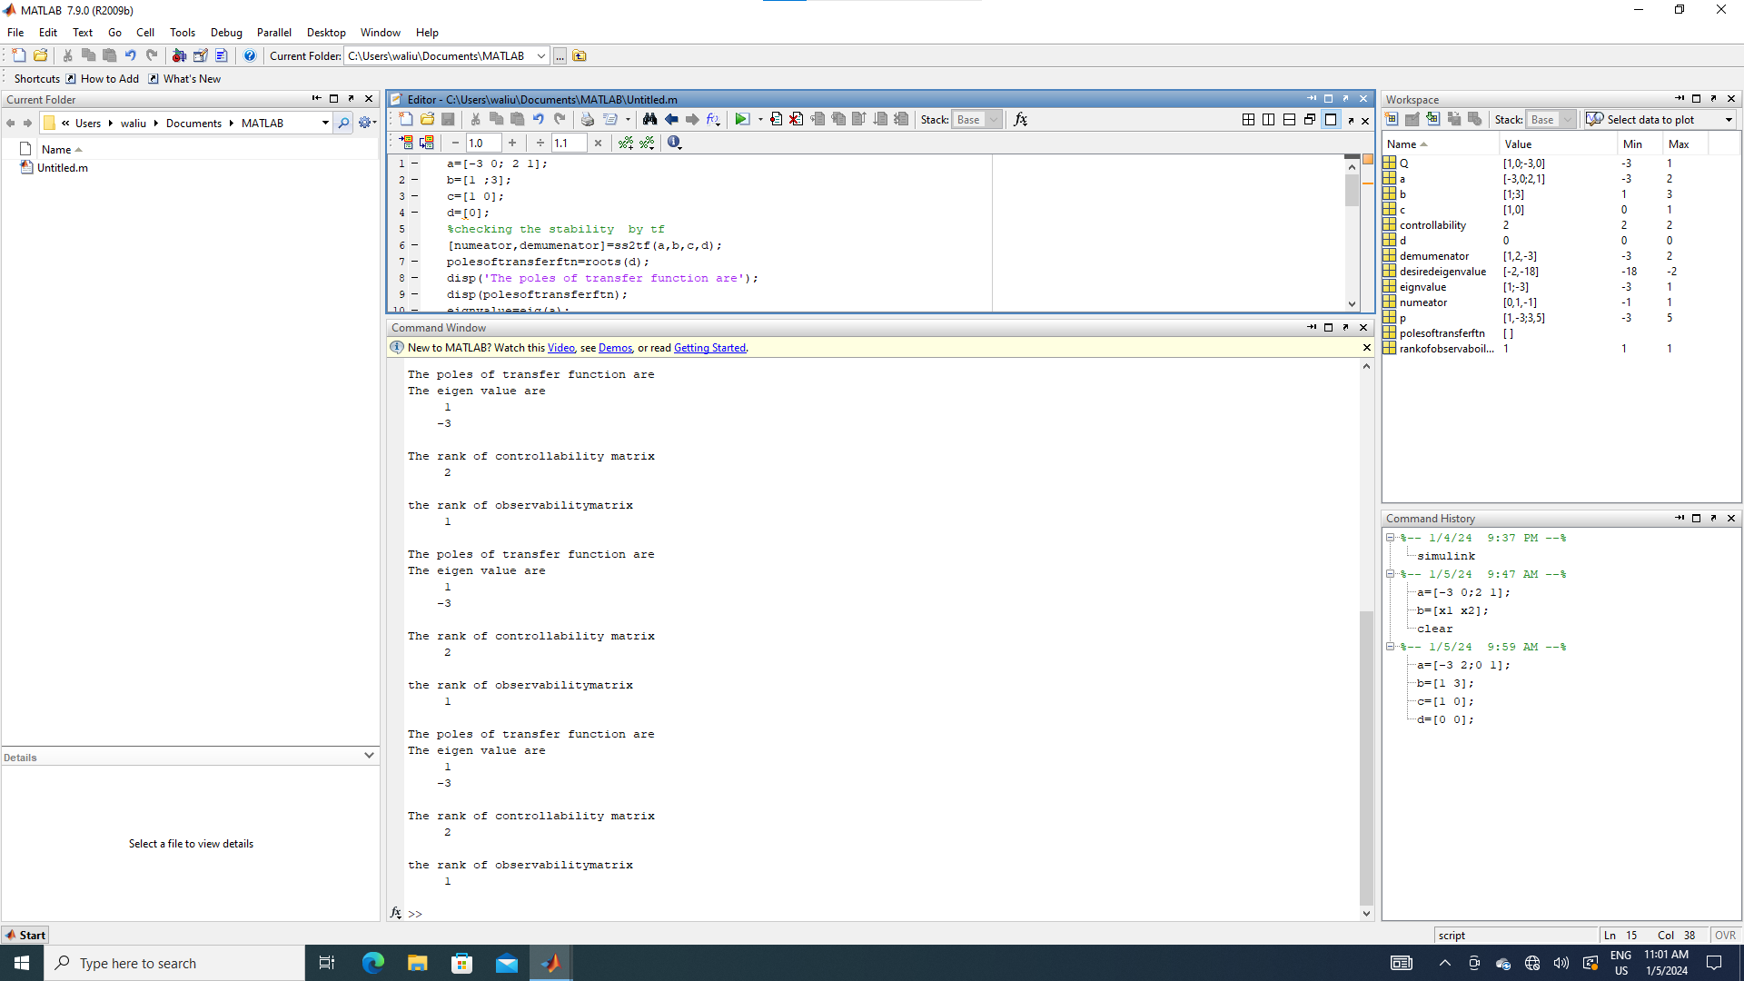

**Reason :**

So we cannot design controller in this case because rank of matrix A is not equal to rank of Matrix Q

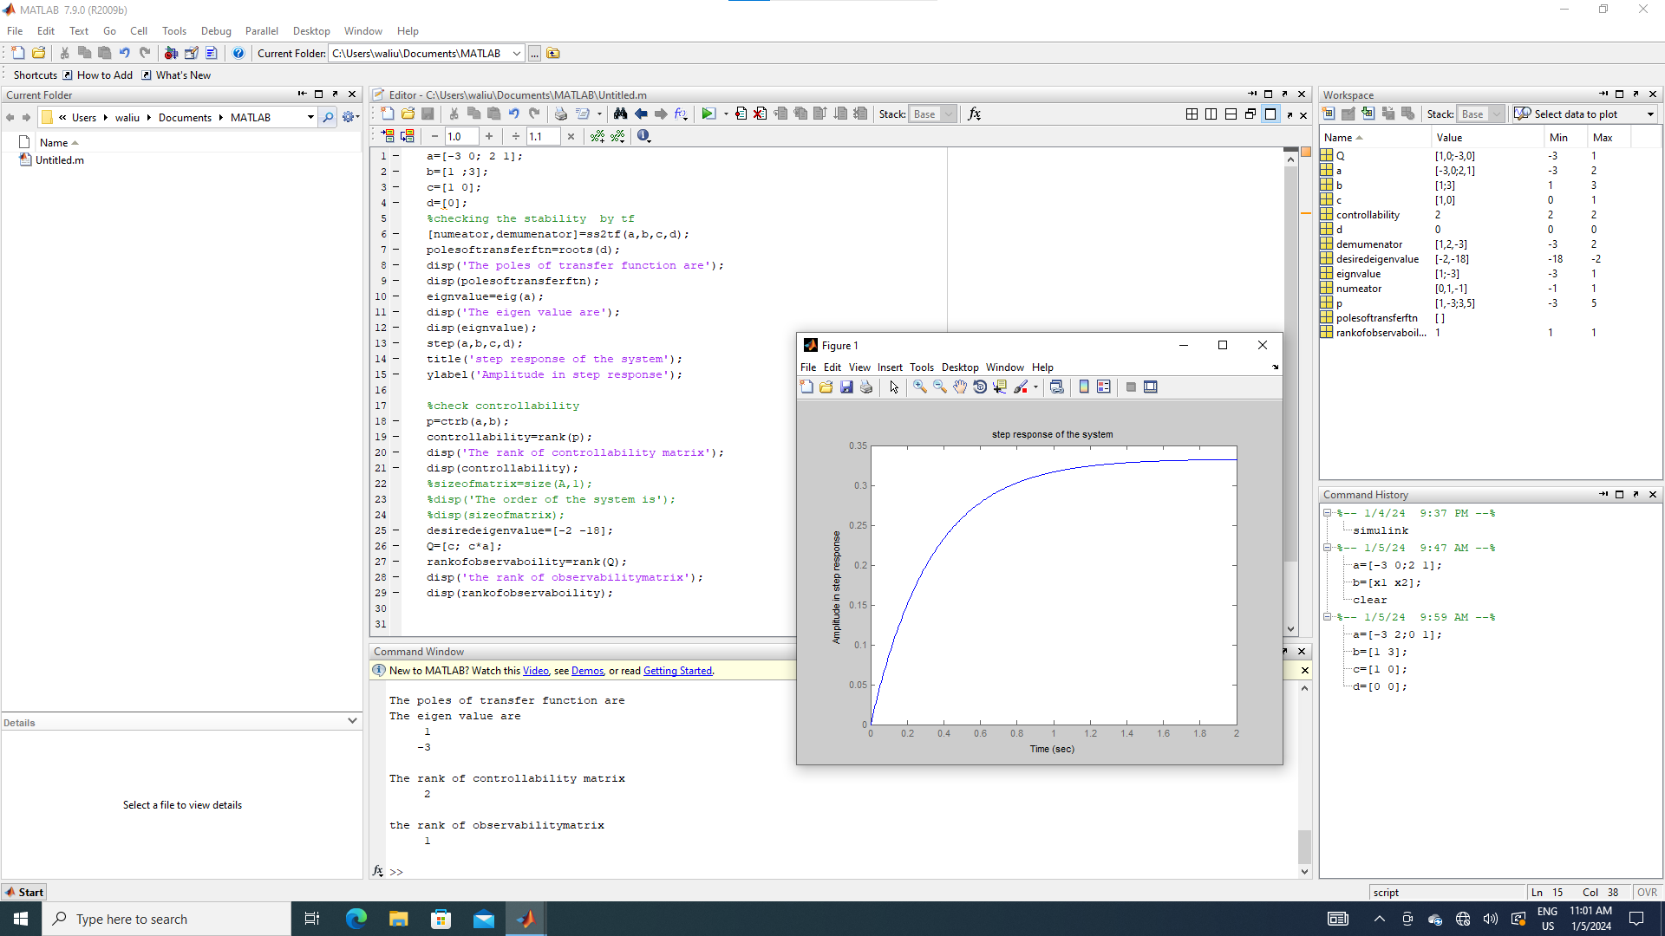

Figure : workspace output